Spooner HHSRS Scoring Sheet v4.1
I recommend watching the Training Video here - https://youtu.be/LL0TTIZAEdg
Enable Macros when prompted on opening of workbook
If the warning below appears, you will need to contact your IT department to gain access to the sheet.
Enter property details – to pull EPC you need at least Property Name/Number and Postcode

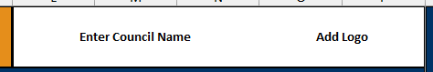
Add council name and logo in the boxes
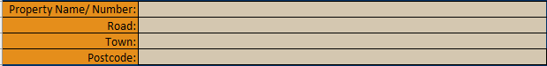
Enter Officer Name, Case Reference and Inspection Date – Must have Case Reference entered to ensure data saves and loads correctly for multiple hazards.
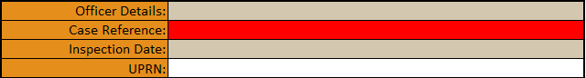
Enter property type from drop down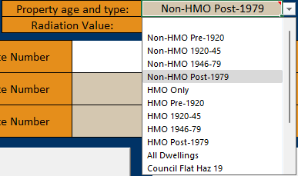
Enter EPC, EICR and Gas Safe details if wanted/needed
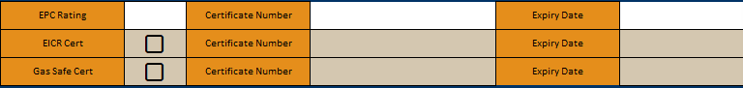
Select Hazard number from the drop down – the notes on this cell gives you all the hazards
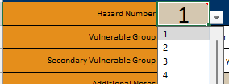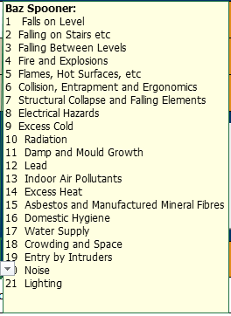
Add any additional notes you may want
Enter property description


When a hazard number is entered, the corresponding hazard case studies will load up on the side bar
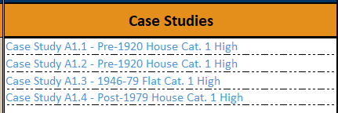
Add in the Hazard Deficiencies

Add your Baseline Indicators
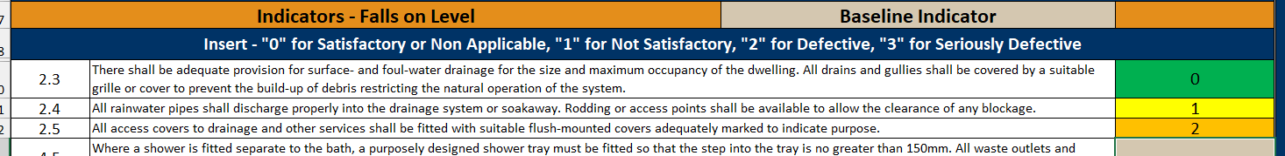
This can be changed to Guidance Notes if needed/wanted from the drop-down menu
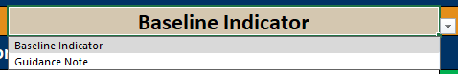
Add your Matters Affecting Likelihood
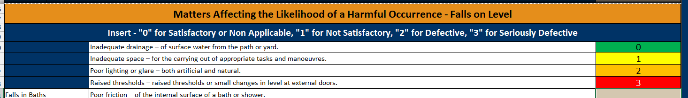
Select your case likelihood from the drop-down menu
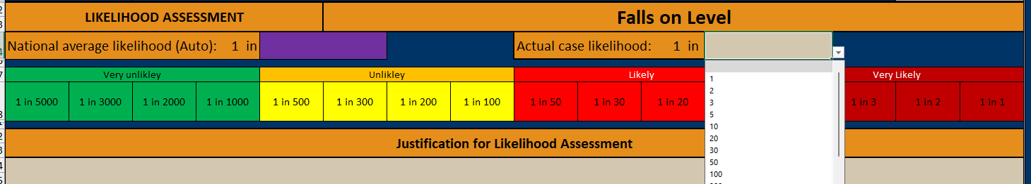
National Average will be auto filled dependant on hazard and property type. National Average will be purple in the scale below, Actual Case Likelihood will be black. If they are the same value case value takes precedent.
Add your own Justification in the box below

Add your Assessments of Outcomes from the drop-down menus
The last
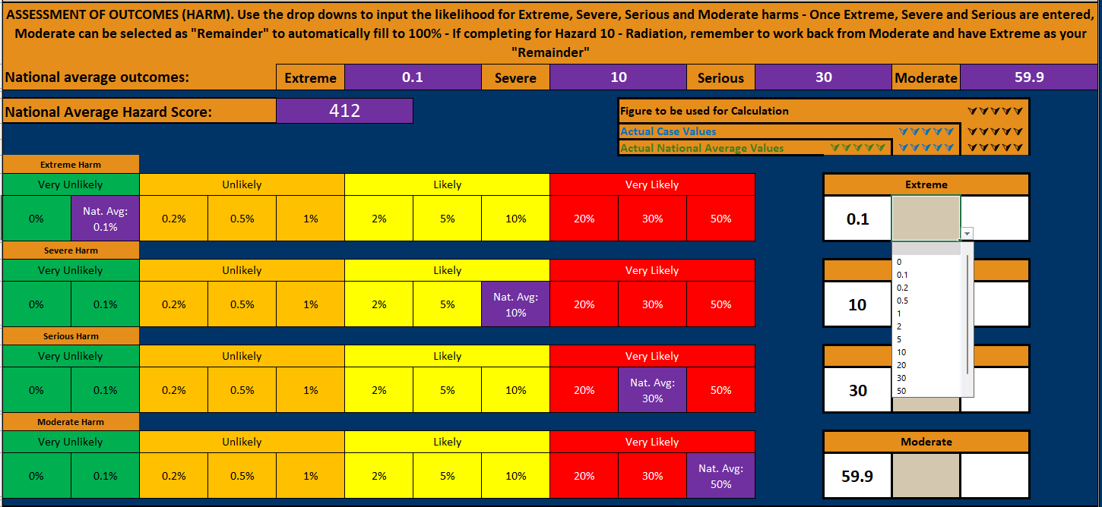The last value you enter can be selected as “Remainder” to ensure the total value is 100
Add your justification – The Hazard Score will now be displayed.
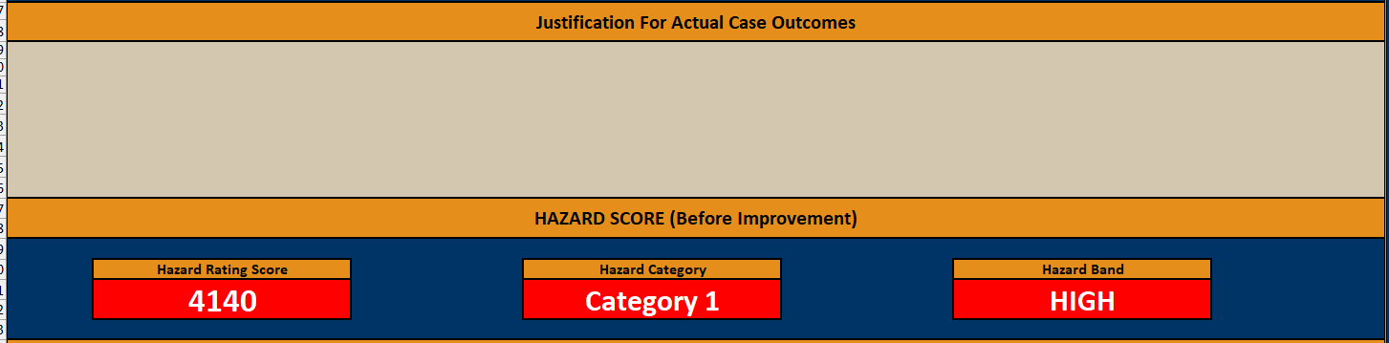
Enter your own text into Schedule of Works
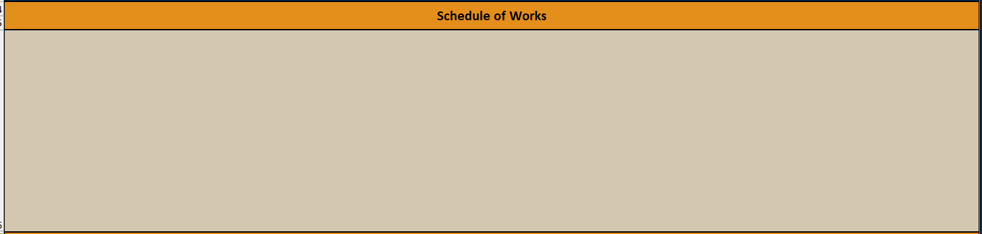

Adding another hazard to the same property.
Click the “Save Hazard” button. Located in the side bar beside Schedule of Works at the bottom of the sheet or Officer details at the top

This will bring up a popup stating “Hazard Saved. Form cleared and ready for the next hazard” – Click “OK”
When Hazards are saved they are stored on the “Hazard Data” tab with all the data entered
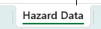
Property Details, Description, Etc will not be removed.
Ensure the case reference is the same – This will not be removed after saving.
Change the hazard number and complete the sheet in the same way as before, once finished click “Save Hazard”
This can be done for every hazard if needed and will be saved for recall later – As long as the case reference is the same.
When hazards are saved they will also be imported into the “Full Landlord Report” tab. This is for easy printing for the landlord, letting agent or saving to DMS
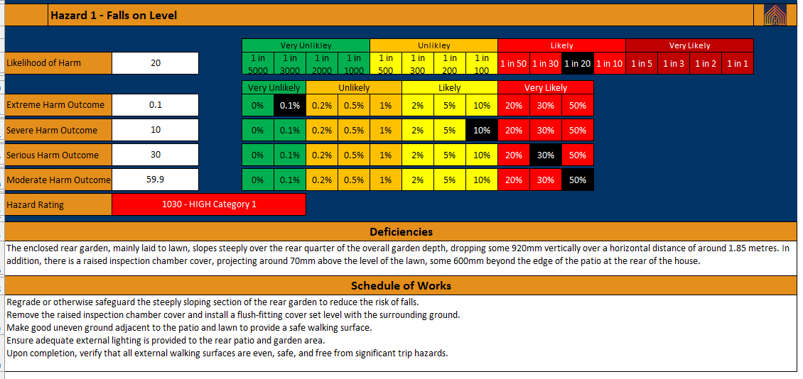

Saving to PDF
There are Print to PDF buttons on both the “Front Sheet” and “Full Landlord Report” tabs. These both create different PDF’s.
- On the front sheet this creates a full printout of the entire front sheet and saves in the folder where the spreadsheet is saved as below:
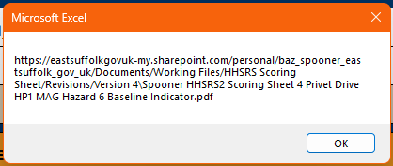
This file name will change dependant on which hazard is selected and whether BI’s or GN’s are selected. If you would like both to be saved, change the Baseline Indicators to Guidance Notes and re-save.
- On the full landlord report this saves in exactly the same way, but uses the case reference as the save name
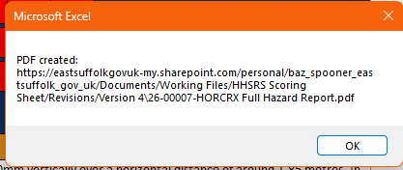
It will create a PDF printout of all the hazards entered in an easy to read format, with each hazard separated on each page.

Load a previous hazard
Ensure that the previous hazard has been saved.
Select the Hazard Number you require to be recalled.
Click the “Load Hazard from Data” Button

This will recall all the entered information for said hazard.

Delete Current Hazard
If you wish to delete a Hazard that has already been entered.
Select the hazard number in cell D20
Click the “Delete Current Hazard Button”

The current hazard will be deleted, nothing else will be affected.

Clear all hazards for current property
If you wish to remove all the hazards stored from a property, click on the “Clear All Hazards from Current Property” Button.
A popup will appear:
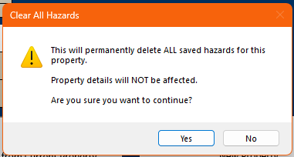
Click “Yes” if you wish to proceed.
This will as stated remove all the stored Hazard Data, this is not reversible

To start a new property.
I would advise to click “File” and “Save a Copy” – save this as you property address or case number – whichever you prefer.
Click the “New Property” button
Again a warning popup will appear – click “Yes” if you are happy to proceed. This is not reversible
Restart as before.

